

**Name: Jarrett Bay 46′ Grander**

**Price: 700$/hour**

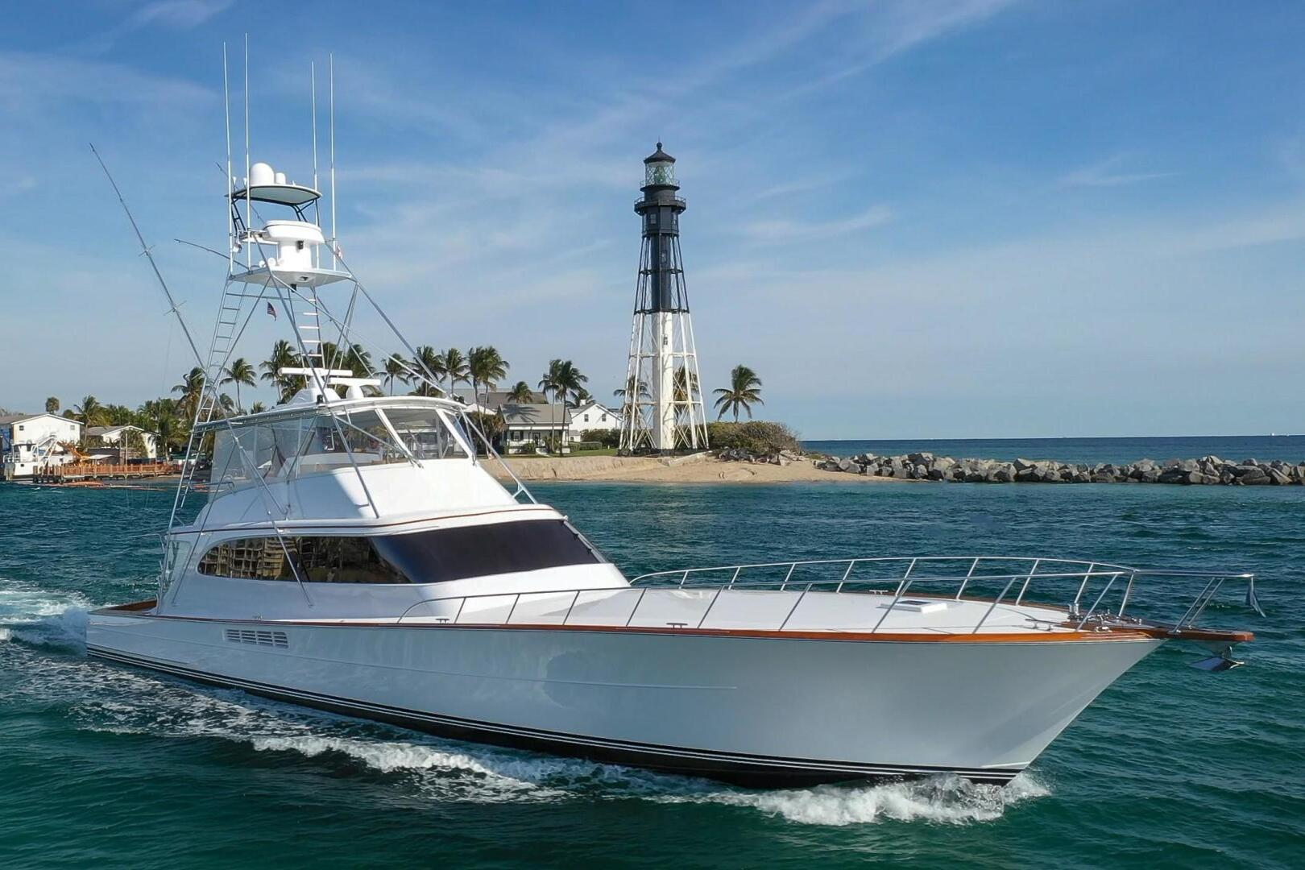

Jarrett Bay 46′ Grander is a yacht that was launched in March 2021. The American cruiser is suitable for family picnics with 2 characteristic elements: High speed and cabin.

Experience amazing adventures with Merry Fisher 795. Superior functionality combined with top-to-bottom comfort. With unlimited flexibility of seats in the cockpit and a spacious salon in the front cabin. Complete with a recreation center and a large swimming deck, this daring cruiser will bring a lot of great things to your trip.

|  |  |
| --- | --- |
|  |  |
|  |  |
|  |  |
|  |  |

|  |
| --- |
| ***​*** |
|  |
|  |

***​ ​DESCRIPTION***

|  |  |  |  |
| --- | --- | --- | --- |
|  | **Long 8m** |  | **Wide 2.5m** |
|  | **1 Room** |  | **8 Guests** |
|  | **1 x 300 HP** |  | **69.54 km/h** |
|  | **Day Charter** |  | **30 L/h** |

ROAD CHARTER

»» Sightseeing on the Saigon River by yacht in 2 hours.  
1. Sunset and city night life.  
2. Enjoy the freedom & fresh air.  
  
»» Saigon – Can Gio Mangrove Forest 4 hours.  
1. Enjoy the mangrove forest and the life of local fisherman.  
2. Buy and cook local seafood from the forest fisherman. The special seafood of brackish water.  
3. Sunset on the river  
4. Night life of the city  
  
»» Saigon – Vung Tau City  
1. The trip will go through Can Gio Mangrove Forest.  
2. Swimming in the open sea (near the coastine)  
3. Sunset on the river  
4. Night life of the city